IBM Telco Customer Churn — Business Report
Executive Summary
The analysis of the IBM Telco Customer Churn dataset reveals significant patterns driving customer attrition. The company currently serves 7 043 customers, generating $456 116.60 in monthly revenue and $16 056 168.70 in total revenue.
The overall customer churn rate is 26.5%, meaning more than one in four customers discontinue their service. This level of churn represents a substantial risk to recurring revenue and long-term profitability.
The findings indicate that churn is strongly associated with:
- Short-term contracts
- Fiber optic internet services
- Electronic check payments
- Higher monthly charges
- Certain demographic groups, particularly senior citizens
These insights provide clear opportunities for targeted retention strategies and operational improvements.
VISUALISATIONS

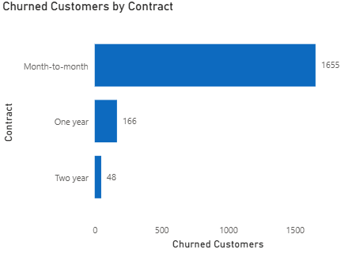

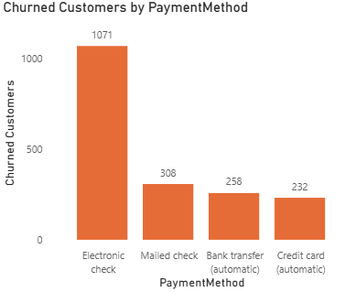

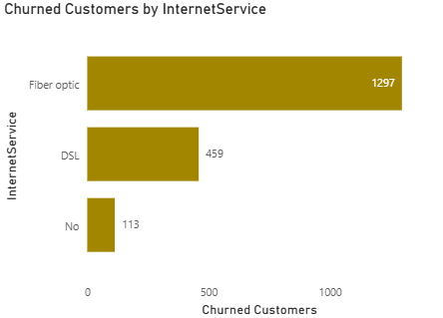

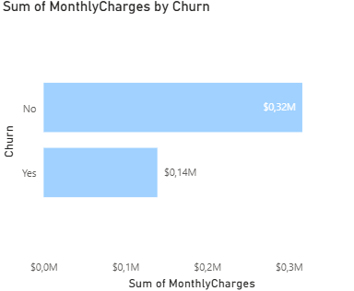

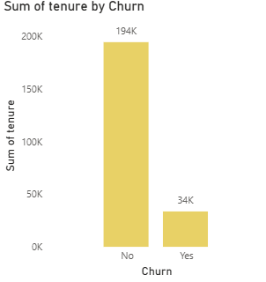

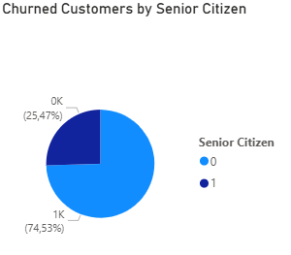

KEY INSIGHTS
1. Customers Without Long-Term Contracts Churn More Frequently
Customers on month-to-month contracts show significantly higher churn rates compared to customers on one-year or two-year agreements.
Possible Drivers
- Minimal switching costs
- Lack of contractual commitment
- Easier comparison with competitors
- Increased price sensitivity
Business Impact
Short-term customers create unstable recurring revenue streams and require continuous acquisition spending to replace lost customers.

2. Fiber Optic Customers Exhibit Higher Churn
Customers subscribed to fiber internet services churn at a notably higher rate than DSL customers.
Possible Drivers
- Higher pricing expectations
- Service reliability or performance issues
- Customer dissatisfaction relative to cost
- Competitive alternatives in high-speed internet
Business Impact
Fiber customers are often higher-value customers. Losing them results in disproportionate revenue loss.

3. Electronic Check Users Are More Likely to Churn
Customers paying via electronic check demonstrate substantially higher churn rates.
Possible Drivers
- Lower customer commitment
- Greater payment friction
- Failed or delayed payments
- Financial instability within this segment
Business Impact
Payment behaviour may serve as an early warning indicator for churn prediction models.

4. Senior Citizens Show Elevated Churn Risk
Senior citizens churn more frequently than non-senior customers.
Possible Drivers
- Difficulty navigating technical support
- Billing complexity
- Lower digital confidence
- Service usability concerns
Business Impact
This segment may require tailored communication and support experiences.

5. Higher Monthly Charges Correlate With Higher Churn
Customers with higher monthly bills are more likely to leave the service.
Possible Drivers
- Perceived lack of value
- Price sensitivity
- Better-priced competitor offerings
- Bundled services not delivering expected benefits
Business Impact
High-value customers represent a critical retention priority because they contribute more revenue per user.

STRATEGIC RECOMMENDATIONS
1. Target High-Risk Customers With Predictive Retention Campaigns
Develop churn prediction models to proactively identify:
- Month-to-month customers
- Fiber customers
- High monthly spenders
- Electronic check users
Suggested Actions
- Personalized retention offers
- Loyalty discounts
- Dedicated support outreach
- Early intervention campaigns

2. Improve Customer Onboarding
The first few months are critical for retention.
Suggested Actions
- Simplify setup and activation
- Provide guided onboarding
- Deliver proactive customer support
- Monitor early service complaints
A strong onboarding experience can reduce early-stage churn significantly.

3. Encourage Long-Term Contracts
Increase migration from month-to-month agreements to annual plans.
Suggested Actions
- Offer discounted annual pricing
- Bundle streaming or premium services
- Introduce loyalty rewards
- Provide contract upgrade incentives
Longer contracts improve revenue predictability and customer lifetime value.

4. Reduce Payment Friction
Encourage customers to move away from electronic checks.
Suggested Actions
- Promote automatic payments
- Incentivize credit card or bank debit usage
- Simplify billing processes
- Improve payment reminder systems
Reducing billing friction can improve both retention and cash flow reliability.

5. Review Fiber Service Experience
Conduct a deeper investigation into the fiber customer journey.
Suggested Actions
- Analyse service outage patterns
- Review pricing competitiveness
- Evaluate customer support interactions
- Collect targeted customer feedback
Improving the fiber experience could significantly reduce high-value customer churn.

6. Strengthen Retention Among New Customers
Customers in early tenure stages are especially vulnerable.
Suggested Actions
- Launch first-90-day engagement programs
- Offer welcome incentives
- Provide educational resources
- Conduct satisfaction check-ins
Early engagement helps establish trust and service adoption.

CONCLUSION
The analysis demonstrates that customer churn is heavily influenced by contract structure, pricing, payment methods, and service experience.
The most immediate opportunities for churn reduction include:
- Migrating customers to long-term contracts
- Improving the fiber customer experience
- Reducing payment friction
- Strengthening onboarding and early customer engagement
By implementing targeted retention initiatives and leveraging predictive analytics, the business can reduce churn, improve customer lifetime value, and stabilize recurring revenue growth.

